**Social Network Analysis of the Food Systems Twitter Discourse**

**Authors: Giulia Menichetti, Rodrigo Dorantes Gilardi, Maggie Clark**

**Introduction**

Food systems have become an increasingly valuable way to understand the issue of food security in a progressively globalized world. The term encapsulates a structure of economic, environmental, and social industries which coordinate the production and distribution of food to consumers and corporations on large and small scales, from global to region to local. Some major components of the food system chain (The Food Systems Dashboard, 2020) include the food supply network, which describes growers, producers, processors, and transporters of food: the providers of arguably the most important product of commerce. Food distributors, marketers and vendors, along with the consumers or recipients make up another link of the chain, with voices on the quality of the food access they receive. The environment and those affected by changes to the environment as a result of food production or distribution are additionally involved in the food system, while simultaneous participants in it. Such an incredibly extensive network leaves opportunity at every link for mismanagement, subpar services or direct violation of rights, and the evidence of these issues in food systems is robust (Passidomo, 2013). In the company of injustice is nearly always the activist, and efforts to “transform” food systems (Ingram and Thornton, 2022) into more ethical structures, socially and environmentally, are prevalent as well. Unfortunately, discussion of food systems on globally scaled advocacy has been minimal. At the 2021 United Nations Climate Change Conference, food systems failed to make the agenda for a single day of the two-week schedule. The impact of climate change on food systems is likely to dramatically reduce crop yields and diminish nutritional value of what can be produced. These developments will slow efforts to eradicate hunger, and food policy experts call for rises in food access research in order to combat such a future (Sulser et al., 2021). The United Nations Food Systems annual summit consistently establishes action plans in support, but the movement lacks international attention. Director of the International Centre for Climate Change and Development Saleemul Huq argues these action plans can be made reality by “relevant actors, which could be governments, it could be coalitions of the willing, it could be U.N. agencies, it could be philanthropies — whoever is interested…the alliances we’ve created are the ways to go,” (Devex, 2021). Food systems needs to draw from individuals and groups already dedicated to the amelioration of a particular social, environmental, or political issue with some connection to food systems. While there is extensive knowledge existing on the changes which need to take place in regards to food systems, there still lies a significant communications issue. “Coalitions of the willing”, or activist organizations, require platforms of outreach, discourse, and connection with one another to create effective movements. One of the most powerful media services which has grown capable of achieving this is the social app Twitter.

Activism on Twitter has seen a great deal of change in the app’s lifetime since 2006, and remains a prominent source of engagement in discussion on the primarily text-based platform (Housley et al., 2018). While its purpose is not for social justice related work, many existing groups and users remain active on the site with that goal in mind, hoping to stir discussion, unite others to their cause or against another, or gather traction for narratives or aid opportunities. In time, Twitter users even began to use their connections on the app to develop activism networks through the platform which hadn’t previously existed. It offers a plethora of advantages to an activist group. It centers promoting users gaining attention and in so, aids in stirring engagement. Twitter’s emphasis on text and character limits requires quick tagline posts which lend themselves well to activist slogans, especially the use of “hashtags”, which allow the user posting to connect themselves to subsections of Tweets all using the same linked phrase. Twitter is affordable and accessible to most, creating a space where users feel they are directly engaging with both their similar-sized platform mutuals and major users with large followings (Scholars Strategy Network, 2017). Advocates of social causes who have utilized the platform remark how easily Twitter allows them to engage with news “live”, or as it is occurring, and view both their native news platforms' perception of events but additionally, the perspectives of news networks and individuals based on where the events are happening. They were able to stay intensely engaged, by the day or the minute if they desired, with issues they cared about. As leaders, they could spread their message and connect users of the apps to outside resources to develop their activist campaign. Twitter could connect them much more quickly than they might have been able to in person or on another social media that fosters relationships built outside the internet. (Hashtag Activism) It can build networks across countries and across the globe of like-minded individuals who long to achieve a common good.

Twitter provides a unique opportunity to develop an activism communication network which lacks wide outreach and consistent conversation. We identified this platform as a potential source of bolstering food system communication. Through the development of social networks representing connections between users posting, sharing, and interacting with food systems content and the usage of food systems related hashtags, we analyzed the food systems community on Twitter. This investigation produced themes in structure, timing and topic of discussions, influence of various users and types of users. Understanding of the network characteristics allowed us to devise recommendations for the development of online food systems communication, which might bring more attention to the issue on an international level.

**Results**

**Section 1 - Analysis of Food Systems Twitter User Network**

While Twitter is largely viewed as solely a social tool, it has largely advanced in usage by major political powers and organizations (Goritz et al., 2019). Political leaders, social change organizations, solo activists, authors, and academics represent just a few of the types of users we identified which participate in the food systems discussion. We manually developed a list of over 150 Twitter users whom we investigated to have posted tweets regarding food systems, then drew data related to their personal Twitter networks. This included their following list, and from this list of users and their collection of Tweets, we were able to coagulate a community of users which communicate with one another regarding food systems and have varying levels of influence. Extracting data from Twitter requires requesting access and use of the Twitter API, the company’s application programming interface. The Twitter API provides a wide variety of data which researchers can use to learn about interactions on the platform; including information about user’s tweeting, tweeting habits, usage of hashtags and phrases, geolocations, user account information, and more (Twitter, 2022). We decided to interact with the API using the Python language, which meant installing the Tweepy library (Rosselein, 2020). We next wrote script based on recommendations from the Twitter Developer’s portal to extract information about our list of users, their follower counts, and who was tweeting about food systems. Given this data, we were able to load it into the program Gephi to build an undirected graph network of users. Gephi provides open-source tools to visualize and analyze network data (Bastian et al. 2009). The users we selected became the list of 1,260 nodes in our network, and connections between them, 33,476 edges, represented a following relationship. To “follow” another user on Twitter means one receives updates about their posting habits on their timeline, which is the homepage, thus it implies an intention to view and potentially interact with their content.

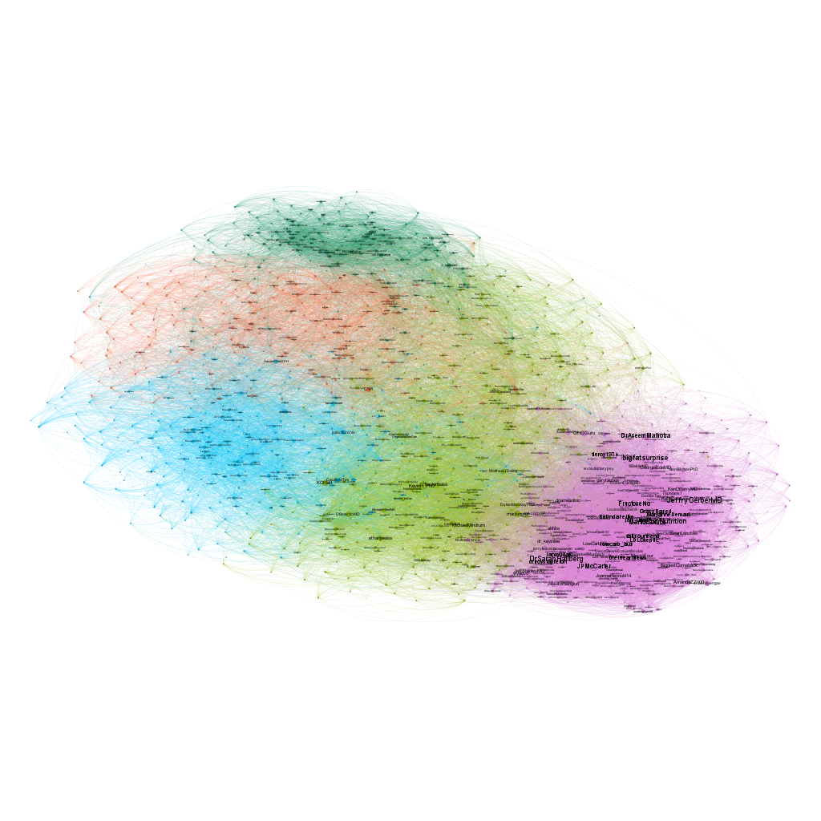

The described user network, with edges visible

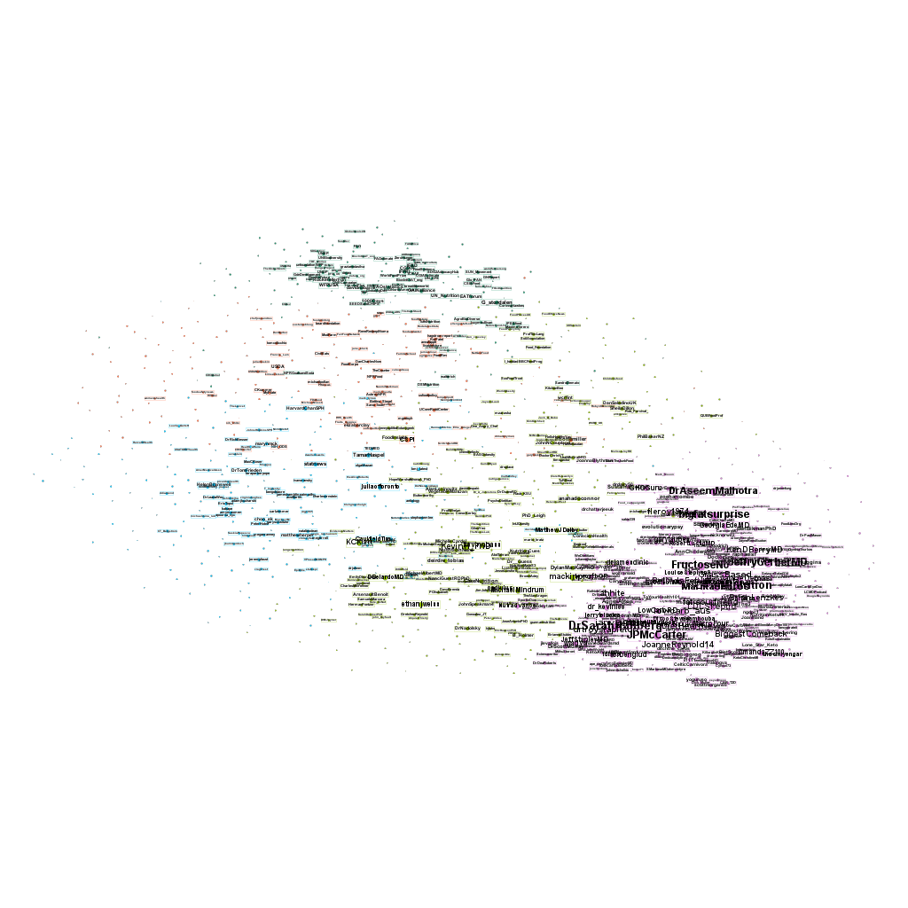

The user network without edges and labels boldened.

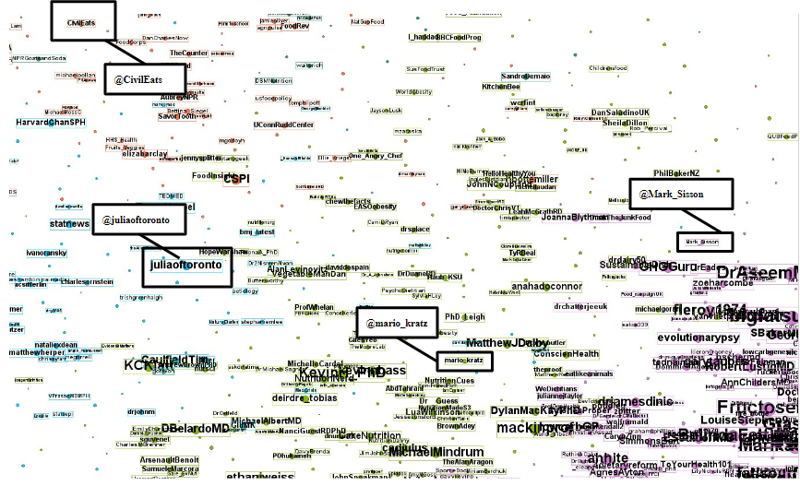

A closeup of blue, orange, light green, and purple modules meeting.

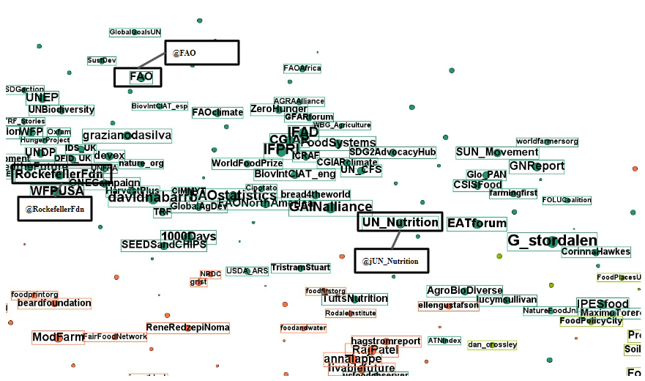

Dark green closely knit module meets orange and light green modules.

In this large network, we perceived divisions into subcommunities. The network is visualized using a modularity algorithm, and in the developed graph, many nodes had connections to those inside its module but few between them. The average degree is 53 edges, a fairly high number, especially considering how separated communities seem to be. This suggests that users are highly connected within their subcommunities, but few are reaching beyond their immediate circle to the larger network.

What was especially notable about these divisions was that the similarity that users in them seemed to share was the career type of user they were. In the largely purple section, there is a high probability a selected node represents a doctor, a media outlet or character, business, or social media influencer whose platform strongly centers around the concept of nutrition. There is evident overlap in the concept of nutrition and food systems, with the quality and structure of a given food system influencing the type and abundance of food which is available to a person or group. While these users may be vocal in discussing a food systems subject, they may also be less likely to be publishing and interacting with content regarding food system activism. One of these users is @Mark-Sisson, a New York Times bestselling author of the book, *The Keto Reset Diet*. These users tend toward the audience of the consumer, who seeks advice about improving their diet. Between this community and the farther communities iss less tightly connected group of light green users with accounts mostly run by medical professionals such as doctors and dietitians, nutrition scientists, and some journalists who in name may seem to offer the same type of nutrition-centered content as the preceding community, but in reality are more related to activism efforts, such as user @mario_kratz, a Nutrition and Chronic Disease Researcher working toward chronic disease prevention. One consistent type of user which seemed to transcend community boundaries was the journalist, who appeared in almost every group. However, there is a collection of blue nodes which has stronger rates of journalism than others which is connected to this group of users pursuing medically-related activism. It also carries a prominent portion of authors and other writers, such as political columnists. This community features users similar to @juliaoftoronto, a popular health journalist. While they may be highly connected to many of the separated groupings in this graph, they also produce content on a wide variety of content, and are less likely to be mindful about food systems specifically but about activism topics overall which happen to include this subject. The types of conversations these users have based on the purpose of their account informs us on what conversations are likely to happen and when, who is leading them, and how food systems can be boosted to garner more attention.

Close to this grouping is an orange section of tightly packed nodes of journalists, media outlets, journals, and organizations which are more specifically focused toward the topic of food systems reform. One of these is the account @CivilEats, posting commentary and news related solely to the United States food system. Both this community and the community of majorly authors and journalists have some of the most prevalent outreaches into the other sections of this graph, with edges reaching out to the nodes in the sections of largely activism-minded medical professionals and even to the farthest nutrition-minded community. Lastly, the smallest and most tightly knit community with connections to the aforementioned medical professionals and grouping of food systems-focused media is a dark green module of international organizations, nearly all specifically related to food in some way. It includes accounts such as that of @RockefellerFdn, for the Rockefeller Foundation, an American foundation seeking global philanthropy efforts, @FAO, The Food and Agriculture Organization, and @UN_Nutrition. Accounts like these are starting largely followed discussions on select days, but cannot on their own maintain discourse between many users. The heavy divisions of these different communities suggests they are maintaining discussion with one another, discussion which involves food systems to some degree, though not heavily expanding their audience to users who are less similar to themselves. The food systems network could be more strongly connected, likely by individuals with wide-reaching connections but a focus on activism.

**Section 2: Detailed Analysis of 2021 Food Systems Tweets and Patterns of Tweet Counts**

We also pulled data related to the details of tweets which included the phrase “food system” from 2021. This provided an opportunity to analyze the content of tweets and learn about which accounts and which topics were popular. Details of tweets help inform who is sparking conversations about food systems, what they are tweeting about, and how they are getting their message out there. The food system is a complex subject with many moving pieces, and it can be flawed to characterize its discussion into solely Tweets which use the specific phrase. While Tweets which don’t use the phrase food system can sometimes be categorized as still about the subject, often that is a question of the user’s intent which we are unable to determine. For this reason we centered our focus of the discussion on Tweets which directly reference food systems as a whole. In the top 20 “food system” tweets of 2021 ordered by likes, the Rockefeller Foundation shows up four times, Economist Impact shows up three (and then four more times shortly after). The Rockefeller top tweets occur when they appeal to younger audiences (showcase youth activists, request for interaction from youth such as to send in justice-minded videos). Two of the top accounts were environmental activism specifically, and we also see accounts famous for reasons outside food systems activism gaining traction, such as Kamala Harris, The Daily Show, and the Bezos Earth Fund. The vast majority of the top tweets are from organizations or official accounts reporting about news, posting resources, or appealing for interaction. Only two of the top 20 tweets commented on food systems discourse (rather than directly discussing food systems themselves) and the top users are almost all officials of nations or organizations, suggesting most of the conversation is not upheld by the average Twitter user. The majority of the conversation around food systems seems to be started by organizations with large influence, and then upheld by interactions of accounts like their own as well. In terms of content, the major event of the year is the Food Systems Summit, with eight of the top 20 tweets directly referencing it. Several others are based around timely events as well, such as International Youth Day, Thanksgiving, or the United Nations General Assembly. From this information we can infer what the strongest contributors are to sparking food systems discourse on Twitter. Timely events, such as international holidays or summits, are what spur conversation, which is often led by organizations. The first highly engaged users to tweet on heavily trafficked (in terms of food systems) days are said organizations (UN, WHO, ECLT), following them are political leaders, and then activists. The engagement they see is majority likes with secondarily retweets. Often they are tweeting the same if not similar hashtags and phrases, though these common hashtags/phrases and the subject area of the tweets can be different based on the community these groups are in. For example, Joyce Bagala Ntwatwa, the Women’s representative of the Mityana District of Uganda, uses the hashtag #YouthDayUG2021 (UG meaning Uganda), whereas many top similar tweets use the hashtag #InternationalYouthDay or #InternationalYouthDay2021. African accounts are particularly active and reach extra acclaim. Most conversations die out as the day goes on, and by the following day or so, the discussion is virtually dead. Many of the top tweets link to outside sources, showing that top tweeters may be using Twitter as a platform to showcase other resources they provide, rather than tweeting for the purpose of a Twitter conversation (trying to keep the user on Twitter, engaging with them there). Additionally, a lot of these top accounts will have one or two popular tweets that day, but won’t be actively tweeting consistently throughout the day and receiving the same interaction.

This trend of sparked conversations which quickly die out is not unique to 2021. We tracked data on the number of tweets using the phrase “food system” in 2019, 2020, and 2021 for analysis of consistency of conversation.

The shortened list of tweet counts using the phrase “food system” in 2019.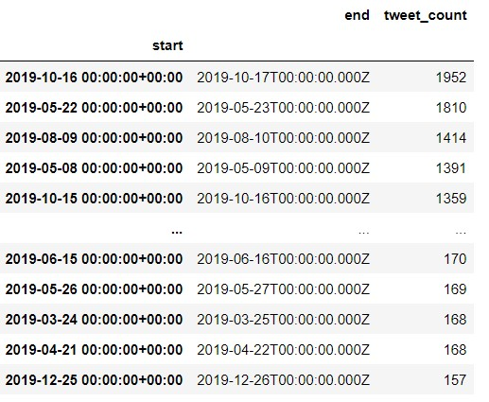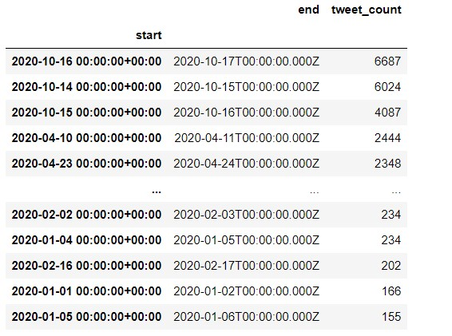

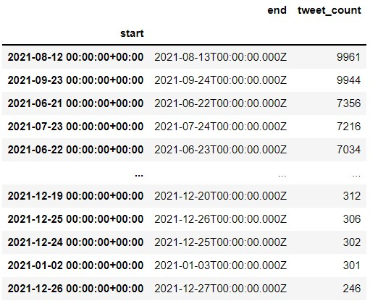

The shortened list of tweet counts using the phrase “food system” in 2020.

The shortened list of tweet counts using the phrase “food system” in 2021.

Food systems tweet rates in each year saw sparks on specific days that we were able to tie to food systems related events or news, such as summits or international holidays, as we saw in the 2021 detailed Tweet data. Between the sparks, discussion drops dramatically. On the most highly Tweeted days for food systems in 2020, tweet counts came in roughly between 4000 and 6000 Tweets using the phrase. The top three days were all between the 15th of October and the 17th of October, with the 16th of October being World Food Day. Days without notable events and drops in conversation tended to see between 200 and 300 tweets. In contrast, climate change maintains higher rates of conversation with less division between its less talkative days and louder days, with a more consistent discussion.

**Discussion**

**Section 3: Limitations of the Food Systems Twitter Discourse**

Evidently, there is a structure for food systems discussion on Twitter, but we still perceive issues impending Twitter discussion of food systems activism. Activist organizations can be relied upon to draw larger masses of viewers than some individual activist accounts, and can be expected to start conversations on holidays. There seems to be a top down approach with a weak base; major accounts tweet to kick off the conversation, and then leave the interactions to smaller accounts similar to their own, which tend to fizzle out quickly. We saw some efforts, for example by the Rockefeller Foundation, to pursue youth interest for activism. Though largely inconsistent, discussion did have reliable spikes on important days. In this discussion represented by the large network we developed of users tweeting about food systems, we saw several stark divisions into subcommunities. This is preventing the collective mind of the food systems discussion from advancing, with users who already interact with one another staying connected and failing to expand outside their smaller networks. Users might only be aware of people in their circle talking about food systems, in the specific way they are discussing it (in reference to nutrition, or news stories, or another subcategory fitting their user type). They would then be unaware of the larger discussion happening, and food systems fail to gain the larger recognition on the app which it is capable of. People from currently disconnected communities need lines of communication to one another.

From analyzing the content of food systems Tweets, the users leading discussion, and the rates of tweeting, we also recognized a lack of polarity and personality to the food systems discussion. One of the most reliable ways to spark discussion of a subject on social media, especially to encourage more consistent discussion by users which might not be organizations, is to spark debate. Food systems is not a simple concept, and not one which every user would necessarily be able to define or even recognize. Thus users are overall less likely to engage with the topic. The existence of food systems is also less controversial than a subject like climate change. However it would be possible to spark debate over a subtopic, which often occurs in the climate change discussion sector; one event or push for legislation regarding a subset of the larger topic becomes a debate. The online controversy feeds a debate, and more users begin talking about climate change (Sanford et al, 2021). The coordinated effort to improve food systems across the globe is also less recognizable as one larger movement than that to fight climate change. (Garimella et al., 2016) noted with built networks of conversation over a hashtag how dramatically controversy changes the structure of a community of discussion on the app, and how that element of polarity can boost the popularity of a topic. Food systems also lack personality; users are less likely to have personal narratives related to it as a whole. Rather, a better phrasing may be that people often don’t realize they have personal narratives related to it. Personal connection by activists and masses to a topic is incredibly important to the effectiveness of the subject’s large-scale demonstrations. The internet, especially social media apps meant to boost the voices of users, can aid in strengthening weak ties between communities and expanding the reach of activism efforts across great distances. (Bennett et al., 2003) Food system amelioration is a global issue, and global coordination is necessary to address it. The lack of public understanding of the issue and its many parts, thus its potential to find a connection to many different groups, is crippling the ability of food systems to become a more frequently discussed worldwide activism effort.

**Section 4: Strategies to Connect and Expand Food Systems Twitter Network**

Based on our analysis on the current limitations of the Twitter food systems network, we recommend the following strategies to improve the frequency and reach of discussion. As mentioned, the food systems network lacks the element of personal narratives. A useful strategy would be to base activism around participatory politics. If organizations or activists who seek to improve discussion could encourage that kind of activism in their own communities, it would do more to boost regular conversation of food systems rather than conversation that only spikes during major events. Strategies for participatory politics emphasize the importance of knowing what is important to your audience: this includes the types of users and news they currently follow, and how you connect your effort to them. Inventive storytelling and pop culture references can be small, fruitful programs for spurring discussion (Soep, 2014).

The network seems to be missing highly influential users which reach a variety of different communities, who would aid in the participatory strategy. These users would have the ability to spark conversations similarly to the current efforts done by organizations, but with wider audiences, and potentially engage more typical users rather than other organizations. This could be accomplished through trying to boost a current food systems activist on the app until they have a wide-reaching network, but we feel the more realistic strategy would be to seek a user who already possesses this high volume, high diversity group of followers and has mentioned food systems in their Tweet content before, though it may not be their focus. There is evidence that knowledge of a particular individual who has been associated with a cause makes people more likely to engage with said cause (Sabherwal et al., 2021). A person with a specific narrative can be more easily digestible than a complex social justice issue. This user could be encouraged to further discuss the subject, thus allowing food systems to “piggyback” on their popularity. Organizations or activists who seek to boost the food system discussion could connect users with these large platforms to users highly involved in specifically food systems for collaboration.

Another strategy is to boost digital media literacy, especially among youth. To keep discussion consistent, users must be consistently using the app in the first place and engaging with it in diverse ways. This includes liking, posting, retweeting, following, and more. The goal of discussion should be to boost conversation on the app itself, with less reliance on and immediate linking to outside platforms. Food systems being a complex issue demands an understanding of online movement efforts and what terms like it mean. Users are unlikely to discuss something they don’t recognize. Digital media literacy describes one’s ability to interact with digital media, including Twitter media. Diverting resources to digital media literacy education can dramatically increase people’s civic and political engagement. It allows users to view Twitter as more than a social media app. They have an opportunity to perceive and share opinions on subjects which are important to them, and get an idea on how their peers feel. This kind of education is most effective for youth, but evidently possible for other ages as well. (Loader and Mercea, 2011) Despite assumptions all youth are adept at every form of Internet usage, many lack necessary skills to take part in online discussion (Hargittai, 2010). Many of the most highly boosted days we saw for food systems were based around youth activism. Through the engagement of participatory politics, enlisting popular users with diverse networks, and expanding access to digital media education, the food systems Twitter discussion could be meaningfully more consistent and prolific.

**Conclusion**

In brief, we see a great deal of opportunity for growth in the food systems community on Twitter. There are marked divisions in users discussing it, all of whom tend to stay in their communities and few reach out to the larger network. The most prominent leaders of discussion are organizations, followed by activists, political leaders, journalists, authors, social media personalities, and individuals in the medical and academic fields. There are sparks in conversation on dates of major events, such as conferences and international holidays, but little discussion in between these days. Twitter can be an influential tool of widespread mobilization for an activism cause. Justice causes can boost their attention through utilizing polarity and personal narratives. The discussion could benefit from a user or group of users who take on the face of food systems, and already possess large, heterogeneous followings. This should be part of an effort to boost participatory politics for food systems; there is already a structure for this with organizations seeking youth engagement and calling for interaction through their posts, but too few are attempting to pull users off the app and less focus on boosting Twitter discussion itself. Drawing users to engage more with the app is an important strategy, and encouraging digital media literacy could be effective in achieving this. Food systems need average users tweeting about food systems daily. They should be aware of a larger discussion about the subject occurring on the app, and feel involved in a greater activism effort through interacting. Through garnering greater attention on social media platforms, the overall goal would be that food systems become more important to political leaders and international organizations, in addition to more people understanding the cause. This would ideally see food systems included in major summits and conferences, and boost research and international aid resources to the cause. Twitter offers a connection to the masses, which could be utilized to stimulate global change to food systems.

**References**

Bastian M., Heymann S., Jacomy M. (2009). Gephi: an open source software for exploring and manipulating networks. International AAAI Conference on Weblogs and Social Media.

Bennett, W. L., & Activism, C. G. (2003). Strengths and vulnerabilities of networked politics1. Information, Communication & Society, 6(2), 143-168.

Buente, W. (2017, September 29). #activism – how twitter boosts civic activism in 140 characters or less. Scholars Strategy Network. Retrieved from https://scholars.org/contribution/activism-how-twitter-boosts-civic-activism-140-characters-or-less

Garimella, K., Mathioudakis, M., Morales, G. D. F., & Gionis, A. (2016, February). Exploring controversy in twitter. In Proceedings of the 19th ACM conference on computer supported cooperative work and social computing companion (pp. 33-36).

Goritz, Alexandra, Nina Kolleck, and Helge Jörgens. (2019). "Education for Sustainable Development and Climate Change Education: The Potential of Social Network Analysis Based on Twitter Data" Sustainability 11 (19): 5499. https://doi.org/10.3390/su11195499

Hargittai, E. (2010). Digital na (t) ives? Variation in internet skills and uses among members of the “net generation”. Sociological inquiry, 80(1), 92-113.

Housley, W., Webb, H., Williams, M., Procter, R., Edwards, A., Jirotka, M., Burnap, P., Stahl, B. C., Rana, O., &amp; Williams, M. (2018). Interaction and transformation on social media: The case of twitter campaigns. Social Media + Society, 4(1), 205630511775072. https://doi.org/10.1177/2056305117750721

Ingram, J., &amp; Thornton, P. (2022). What does transforming food systems actually mean? Nature Food, 3(11), 881–882. https://doi.org/10.1038/s43016-022-00620-w

Passidomo, Catarina. (2013). Going ‘Beyond Food’: Confronting Structures of Injustice in Food Systems Research and Praxis. Journal of Agriculture, Food Systems, and Community Development 3 (4). Ithaca, NY, USA:89–93. https://doi.org/10.5304/jafscd.2013.034.009.

Twitter. (2022). Privacy | docs | twitter developer platform. Twitter. Retrieved from https://developer.twitter.com/en/docs/twitter-for-websites/privacy#:~:text=When%20you%20view%20Twitter%20content,operating%20system%2C%20and%20cookie%20information.

Roesslein, J., (2020). Tweepy: Twitter for Python! URL: https://github.com/tweepy/tweepy.

Sabherwal, A., Ballew, M. T., van Der Linden, S., Gustafson, A., Goldberg, M. H., Maibach, E. W., ... & Leiserowitz, A. (2021). The Greta Thunberg Effect: Familiarity with Greta Thunberg predicts intentions to engage in climate activism in the United States. Journal of applied social psychology, 51(4), 321-333.

Sanford, M., Painter, J., Yasseri, T., &amp; Lorimer, J. (2021). Controversy around climate change reports: A case study of twitter responses to the 2019 IPCC report on land. Climatic Change, 167(3-4). https://doi.org/10.1007/s10584-021-03182-1

Soep, E. (2014). Participatory politics: Next-generation tactics to remake public spheres (p. 96). The MIT Press.

Sulser, Timothy; Wiebe, Keith D.; Dunston, Shahnila; Cenacchi, Nicola; Nin-Pratt, Alejandro; Mason-D’Croz, Daniel; Robertson, Richard D.; Willenbockel, Dirk; and Rosegrant, Mark W. (2021). Climate change and hunger: Estimating costs of adaptation in the agrifood system. Food policy report June 2021. Washington, DC: International Food Policy Research Institute (IFPRI). https://doi.org/10.2499/9780896294165

The Food Systems Dashboard. Global Alliance for Improved Nutrition (GAIN) and Johns Hopkins University. (2020). Geneva, Switzerland. https://www.foodsystemsdashboard.org. DOI: https://doi.org/10.36072/db.

Welsh, T. (2021, November 3). COP 26 agenda comes up short on Food Systems, advocates say | Devex. Devex. Retrieved from https://www.devex.com/news/cop-26-agenda-comes-up-short-on-food-systems-advocates-say-101962